Using Bloom’s Taxonomy



**Information Sheet**

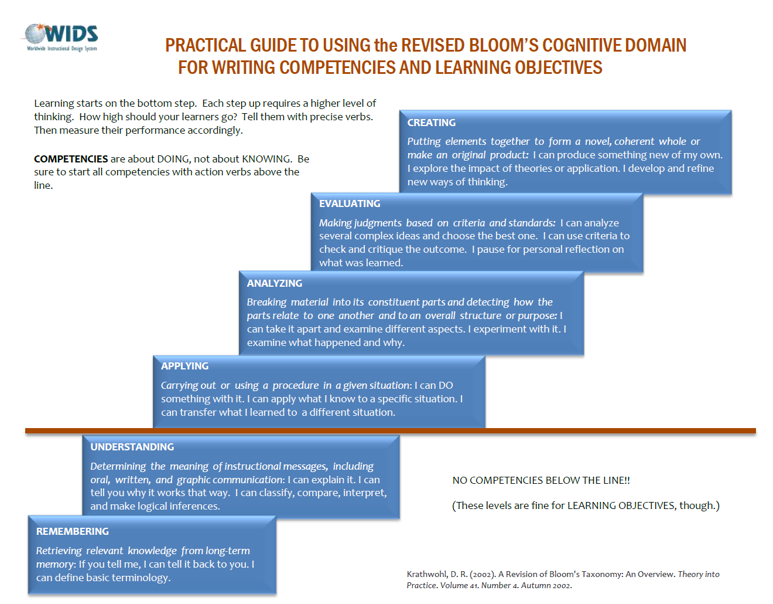

Verb Lists

**Information Sheet**



***Cognitive Domain Verbs***

Verbs in **boldface** appear in more than one column.

|  |  |  |  |  |  |  |  |  |  |  |  |
| --- | --- | --- | --- | --- | --- | --- | --- | --- | --- | --- | --- |
| **Creating** | Abstract  Animate  Arrange  Assemble  Budget  Categorize  Code  Combine | Compile  Compare  Compose  **Construct** Cope  Correspond  Create  Cultivate | Debug  Depict  Design  Develop  Devise  Dictate  Discuss  Enhance | | **Explain**  Facilitate  Format  Formulate **Generalize**  Generate  **Handle**  Hypothesize | Import  Improve  Incorporate  Integrate  Interface Join  Lecture  Model | **Modify**  Network  Organize  **Outline**  Overhaul  Plan  Portray  **Prepare** | **Prescribe**  **Produce**  Program  Rearrange  Reconstruct  Refer  **Relate** Reorganize  Report | | Revise  **Rewrite**  Schematize  Specify  **Summarize**  Support  Write | |
| **Evaluating** | Appraise  Argue  Assess  Choose  **Compare** | Conclude  **Contrast** Counsel Criticize  Critique | **Defend**  **Determine**  **Discriminate**  **Estimate** Evaluate | | **Explain**  Grade  Hire  **Interpret** | Judge  Justify  Measure  **Predict** | **Prescribe**  Rank  Rate  Recommend | Release  **Select**  **Summarize** Support | | Test  Validate  Value  Verify | |
| **Analyzing** | Analyze  Appraise  Audit  Blueprint  Breadboard  Break down  **Characterize**  Choose | **Classify Compare**  Confirm Contrast Compare  Correlate  Criticize  Deduce | Detect  Diagnose Diagram  **Differentiate**  **Distinguish**  **Discriminate**  Dissect  Document | | Ensure  **Examine**  Experiment **Explain**  **Explore**  Figure out  File  Group | **Identify Illustrate**  **Infer**  **Interrupt** Inventory  **Investigate**  Lay out | Manage  Maximize Minimize  Optimize  Order  Organize  Outline | Point out  Prioritize  Proofread  Query  Question  **Relate**  **Select** | | Separate  Size up  Subdivide  **Summarize**  Test  Train  Transform | |
| **Applying** | Acquire  Adapt  Allocate  Alphabetize  Apply  Ascertain  Assign  Attain  Avoid | Back up  Calculate  Capture  Change  Choose  **Classify**  Complete  **Compute**  **Construct** | Customize  Demonstrate  Depreciate  Derive **Determine**  Diminish  Discover  Dramatize  **Draw** | | Employ  **Examine**  Exercise **Explore**  Expose  **Express**  **Factor**  Figure  Graph | **Handle Illustrate**  Interpret  **Investigate**  Manipulate  **Modify**  Operate  Personalize | Plot  Practice  **Predict**  **Prepare**  Price  Process  **Produce**  Project | Protect  Provide  **Relate**  Round off  Sequence Schedule  Show  Simulate | | Sketch  Solve  Subscribe  **Tabulate**  Transcribe  **Translate**  Use  Write | |
| **Understanding** | Add  Approximate  Articulate  Associate  Characterize  Clarify | **Classify Compare**  **Compute**  **Contrast**  Convert  **Defend** | Demonstrate  **Describe**  Detail **Differentiate** Discuss  **Distinguish** | | Elaborate  **Estimate**  Example **Explain Express**  Extend | Extrapolate  **Factor**  **Generalize**  Give  **Identify**  **Infer** | Interact  Interpolate **Interpret**  Locate  Observe Paraphrase | Picture graphically **Predict**  **Recognize**  **Report**  Restate  **Review** | | **Rewrite**  Select  Subtract  **Summarize**  **Translate**  Visualize | |
| **Remembering** | Cite  Count  Define  **Describe**  **Draw** | **Duplicate** Enumerate **Identify**  Index  Indicate | | Label  List  Match  Meet | Memorize Name  **Outline**  Point | Quote  Read  Recall  Recite | Recognize Record  Repeat Reproduce | **Review**  **Select**  Show  State | Study  **Tabulate**  Trace  **Write** | |

***Psychomotor Domain Verbs***

|  |  |  |  |  |  |  |
| --- | --- | --- | --- | --- | --- | --- |
| activate  adjust  align  apply  arrange  assemble  balance  break down  build  calibrate | change  clean  close combine  compose  connect  construct  correct  create  demonstrate | design  dismantle  drill  fasten  fix  follow  grind  grip  hammer  heat | hook  identify  load  locate  loosen  make  manipulate  mend  mix | nail  operate  paint  press  produce  pull  push  remove  repair | replace  rotate  sand  transfer troubleshoot  tune  turn on/off  type  saw | sharpen  set  sew  sketch  start  stir  use  weigh  wrap |

***Affective Domain Verbs***

|  |  |  |  |  |
| --- | --- | --- | --- | --- |
| **Receiving** | ask  choose | follow  give | hold  select | show interest |
| **Responding** | accept responsibility  answer  assist  be willing to | comply  conform  enjoy  greet | help  obey  perform  practice | present  report  select  tell |
| **Valuing** | associate with  assume responsibility  believe in  be convinced | complete  describe differentiate  have faith in  initiate | invite  join  justify  participate  propose | select  share  subscribe to  work |
| **Organization** | adhere to  alter  arrange | classify  combine  defend | establish  form judgments identify with | integrate  organize  weigh alternatives |
| **Internalization** | act  change behavior  develop code of behavior  develop | philosophy  influence  judge problems/issues  listen | propose  qualify  question | serve  show mature attitude  solve  verify |