Performance Assessment Tasks

**Information Sheet**



***Definition***

**Assignments learners must do to demonstrate achievement of one or more competencies. They include directions, a checklist or rubric, a rating scale and a scoring standard. Performance assessment should be criterion referenced which means that performance is measured according to pre-established standards. It may call for demonstration of a process or production of a product.**

**DEFINITION**

Performance assessment tasks are specific tasks or assignments designed to measured outcomes (such as competencies or program outcomes). Since performance assessment tasks usually don’t have a single, correct answer, you can’t machine score them. Instead you need to use judgment. To make sure you evaluate performance consistently, accurately, and fairly, include a scoring guide with your performance assessment.

Performance assessment tasks include several components: directions; a checklist or rubric; a rating scale and a scoring standard.

# Performance Assessment Tasks Checklist

* Performance assessment task targets one or more competencies or other target outcomes
* Performance assessment task is titled
* Performance assessment task includes clear directions for how to perform the task
* Performance assessment task includes a scoring guide checklist or rubric
* Performance assessment task matches the performance standards outlined for the competency(ies)
* Scoring guide includes a scoring standard that details the minimum performance required on the scoring guide for demonstrating competence
* Scoring guide includes a rating scale

# Directions to the Learner

A performance assessment task includes narrative directions for the learner. The directions may include:

* A description of the nature and format of the task.
* Steps for completing the task.
* Information on how the scoring guide will be used.

If desired, build a scenario into your assessments. Scenarios help learners transfer what they have learned to work or life situations. Scenarios place the learner in a simulated work or life-role setting, complete with details regarding the company name, job title, and specific task or tasks to be performed. Scenarios are optional in performance assessment tasks.

# Directions to the Evaluator

Directions to the evaluator clearly describe instructions for setting up and conducting the assessment. They might also include assistance allowed, safety considerations, and other elements as needed.

# Scoring Guides

Scoring guides are tools for focusing your judgment as you assess performance, particularly for assessments which invite a broad range of responses.

Scoring guides are the key to validity, reliability, and fairness in assessment. They provide a uniform set of criteria and a rating scale. As a result, you can evaluate all learners on the same basis, and give learners specific feedback and documentation on their performance.

A scoring guide can include several components:

* Criteria
* Descriptor Columns (for complex rubrics)
* Rating scale
* Scoring standard

# Scoring Criteria

Scoring criteria are the established specifications by which performance of a target competency is judged. They are the heart of a scoring guide. Scoring criteria usually come from the performance standards for the targeted competency. If you have already written those in WIDS, you can link your scoring guide to the criteria.

# Descriptor Columns (optional)

Some complex performance assessment tasks use descriptor columns. Descriptors spell out what is expected of students at each level of performance for each criterion. These are phrases or sentences that describe the qualitative or quantitative differences of the performance along a continuum of performance levels. Levels of performance are used to designate the quality, or how well, the student performed each of the descriptors.

Each column is labeled or given a point value (or both). Commonly used labels include:

* Sophisticated, competent, partly competent, not yet competent
* Exemplary, proficient, marginal, unacceptable
* Distinguished, proficient, intermediate, novice
* Accomplished, developing, beginning

Descriptor columns are optional in a performance assessment task.

# Rating Scales

A rating scale is a pre-established, fixed value used to differentiate among levels of performance. Rating scales might be numeric, letter assignments, or qualitative words.

# Sample Rating Scale

4: Demonstrates mastery, performs with confidence

3: Demonstrates skill in meeting criterion

2: Demonstrates moderate skill in meeting criterion

1: Does not meet criterion, makes a number of critical errors

**Scoring Standard**

A scoring standard establishes the expectations for acceptable performance and can also help you tie performance to grades.

# Sample Scoring Standards

* Sample 1: You must achieve a rating of at least “2” on each criterion to demonstrate competence.
* Sample 2: You must achieve a rating of at least “3” on criteria 1, 3, and 5 to demonstrate competence. (Noting those criteria that are essential.)
* Sample 3: You must achieve a “yes” rating on all asterisked criteria to demonstrate competence.

**How to Create Performance Assessment Tasks**

**Information Sheet**



Performance assessment tasks (or PAT’s for short) are designed to validate a learner's competence. They serve as the tool for evaluating a specific competency or set of competencies, allowing the learner to demonstrate mastery.

*Tip: you should design competencies and performance standards in the Course Outcome Summary tab prior to developing a performance assessment task.*

#### Get Started

Performance Assessment Tasks are created in the **My PATs** tab of the course.

1. Open your course from your home page.
2. Select the **My PATs** tab of your course.
3. Place the screen into **Edit**.



#### Create a PAT

WIDS presents a series of tabs. The **List** tab shows all of the PATs in your course. On this tab you can create a PAT.



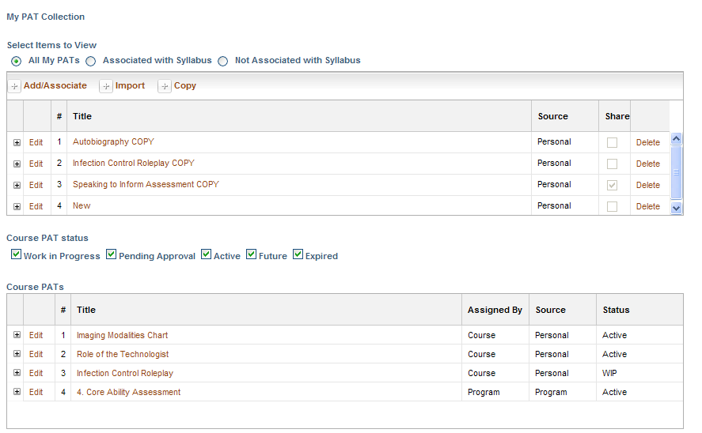

|  |  |
| --- | --- |
|  | The performance assessment task **List** screen includes two grids.   * **My PAT Collection**: This list includes performance assessment tasks (PATs) that belong to you. They may be shared (so they can be copied by other instructors) or not depending on what you select. * **Course PATs**: This list includes PATs that were identified as belonging to the course in the **Course Outcome Summary** tab or assigned by the program. (See the source column.) These will be uneditable to you unless you have an editing role on the **Course Outcome Summary** tab. |
|  | Select **Add, Import or Copy** to create a performance assessment task (PAT).   * **Add/Associate**: Add a new PAT or associate an organization PAT . If you organization has created core ability or general education PATs, you can associate them here. * **Import:** Import a PAT as a copy from another course or the **PAT Library**. This option opens a dialogue box to navigate to find PATs from another course or use the **PAT Library**. The **PAT Library** offers a selection of predesigned PATs for you to edit or revise for your own use. * **Copy:** Copy a shared PAT from this course. You can also use this option to copy one of your own PATs in this course.   **Use Import to choose PATs from the PAT library. Check an item in the list to preview it on the right side of the screen. Click Save to add it to your course.** |
|  | To open a PAT click on the title. To edit the title or the shared properties, click **Edit** next to the title. |

#### Enter PAT Information

Click the **Information** tab to add target outcomes, designate the PAT environment and select evaluators.

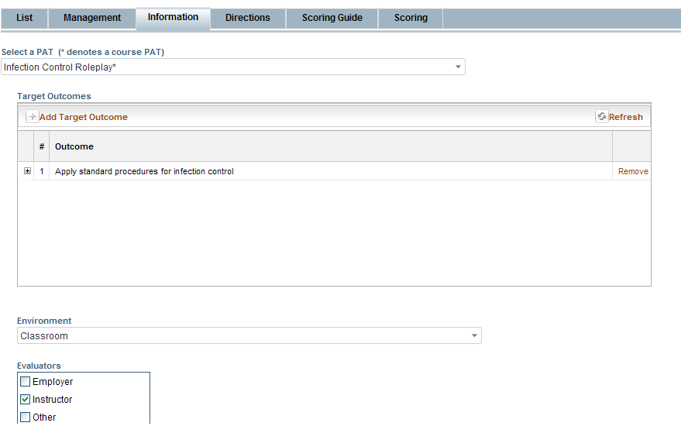

|  |  |
| --- | --- |
|  | Use the dropdown to navigate among your PATs. An * after the PAT title denotes a Course PAT. Course PATs are only editable to people who have edit privileges on the **Course Outcome Summary** tab or (in the case of program PATs) the **Program** or **Org** Module in WIDS. |
|  | Click **Add Target Outcome** to select one or more outcomes to be the target of your PAT. WIDS presents a dialogue box for selection. The selection box will include core abilities (**CA**), program outcomes (**PO**) and course competencies (**CC)** in this course. Note the code next to each outcome when you make your selection. |
|  | Select the **Environment** from the drop list and **Evaluators** for the PAT if desired. Add your own evaluators by typing in the text box. |

**Enter Directions**

Click the **Directions** tab to add directions for the learner and evaluators. Directions tell the learner how to complete the task. They might describe the format of the task and tell the learner how they will be evaluated. If multiple people will be evaluating learners’ work, you might also include **Notes for Evaluators**.

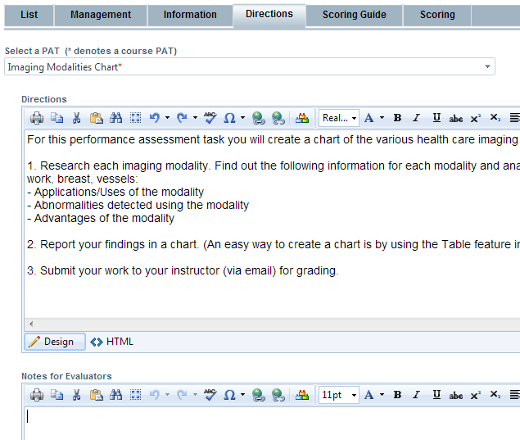

|  |  |
| --- | --- |
|  | Add **Directions** for the learners on how to complete the PAT. You might also include information on how the scoring guide will be used to evaluate their work. |
|  | If multiple people will be evaluating the student work, include **Notes for Evaluators** to increase reliability and consistency among the evaluators. |

#### Create the PAT Scoring Guide

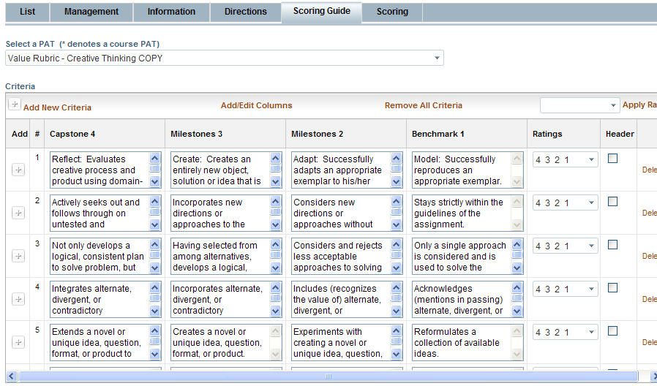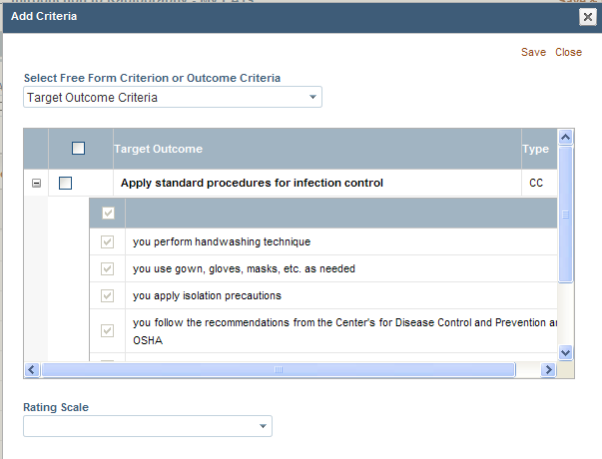Select the **Scoring Guide** tab to create the scoring guide or rubric.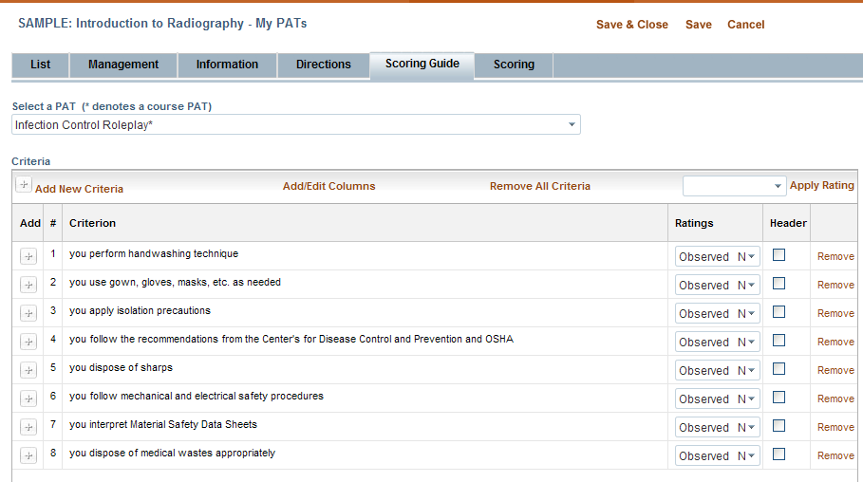

|  |  |
| --- | --- |
|  | Select **Add New Criteria** to add either text rows or performance standard criteria to the scoring guide. WIDS opens a dialogue box with criteria from linked outcomes. Checking a box in the gray header row, will check all boxes beneath it. You can select a **Rating Scale** here too by using the drop list. |
|  | Once you have added criteria, click the **+** sign to add criteria rows as text. This will give you a blank row to type in. |
|  | Change the rating scale for entire scoring guide by selecting a rating from the dropdown and clicking **Apply Rating**. Don’t find a rating scale you like in the drop list? No problem; enter one of your own in the box, and click **Apply Rating**. |
|  | Selecting a row as a **Header** means that it will print in bold. If a scoring guide addresses criteria for multiple outcomes, the outcomes themselves are sometimes designated as headers to make them stand out. You might also add a text rows (such as Product Criteria or Core Ability Criteria) and designate them as headers. |
|  | WIDS supports rubrics with multiple columns. Add, edit, remove or hide columns by selecting **Add/Edit Columns.** |

#### Enter the PAT Rating Scale and Scoring Standard

Rating scales help define the ratings used in the scoring guide. They are not always necessary, but can be useful if you are using an alpha or numeric rating scale. Rating scales can be found under the **Scoring** tab.

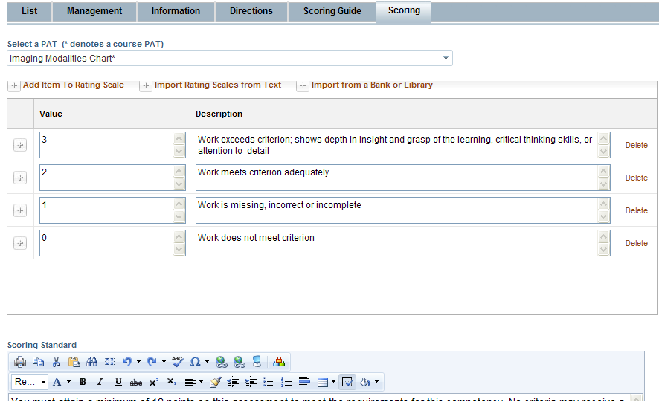

|  |  |
| --- | --- |
|  | Navigate to the **Scoring** tab. Select an option to begin your rating scale:   * **Add Item to Rating Scale**: Add a new rating item. * **Import Rating Scales from Text:** Import a rating scale from text by typing in the box that appears or by using copy/paste from another document. Note—only the rating description comes in using this method. * **Import from a Bank or Library:** Copy a shared rating scale from another course or the library. |
|  | A scoring standard establishes the expectations for acceptable performance and can also help you tie performance to grades. For example, a scoring standard for the sample above might be “You must achieve a rating of at least “2” on each criterion to demonstrate competence.” |

**Sample Performance Assessment Task**

**Discussion Board Entries**

*Directions*

The expectation is that you think about, process and apply the information in the discussion board. Please do not answer with a word or two, or give a basic response such as, "I agree," "I disagree," "Good job," or "Nice response." While all of these could definitely be contained in a response, they are samples of what is considered an incomplete response. In order be successful in this learning activity, compose a well developed, thoughtful response. The instructor may also use this forum to participate in the discussion. While the instructor may respond to individual responses, the instructor will generally respond to the entire class once the Discussion Board has closed (all learners have had an opportunity to submit responses).

*Evaluator(s)*

Instructor

*Target Course Competencies*

|  |  |
| --- | --- |
| 1 | Compare and contrast psychological abnormality from historical perspectives to current views |
| 2 | Summarize current research methods as they apply to abnormal psychology |
| 3 | Outline the multi-dimensional criteria for determining abnormality |
| 4 | Examine major theoretical perspectives within psychology as they apply to psychological disorders |
| 5 | Critique DSM-5 classification system |
| 6 | Summarize the characteristics of psychological disorders |
| 7 | Apply a biological, psychological, and social/environmental framework to the etiology of specific psychological disorders |
| 8 | Investigate the relationship of assessment and diagnosis to the treatment of psychological disorders |
| 9 | Identify potential moral, ethical, and legal considerations/conflicts in mental health fields |
| 10 | Explore future directions in the theory and practice of abnormal psychology |

*Rating Scale*

|  |  |
| --- | --- |
| *Value* | *Description* |
| 3 | Work exceeds criterion; shows depth in insight and grasp of the learning, critical thinking skills, or attention to detail |
| 2 | Work meets criterion adequately |
| 1 | Work is missing, incorrect, or incomplete |

*Scoring Standard*

You must achieve a rating of at least "2" on each criterion to demonstrate competence.

**Scoring Guide**

|  |  |  |
| --- | --- | --- |
|  | *Criteria* | *Ratings* |
| 1 | You respond to each discussion question. | 3 2 1 |
| 2 | You respond to at least two of their classmates discussion items. | 3 2 1 |
| 3 | You accurately addressed all the areas of the discussion questions posed by the instructor. | 3 2 1 |
| 4 | You go beyond simple responses to demonstrate an understanding of the material. | 3 2 1 |
| 5 | You provide an entry to the discussion questions that elicited a response from fellow students. | 3 2 1 |
| 6 | You exhibit correct and appropriate grammar, punctuation, spelling, syntax, and word usage. | 3 2 1 |