**Top Ten Questions Teachers Hate to Hear Most**

**Information Sheet**



Can I do   
extra credit?

**How could I fail? I wasn’t here!**

Is this going to be graded?



What do I need to pass this class?

**Are we doing anything important today?**

Do I have to write this? down?

**When am I ever going to use this?**

(Immediately after taking a test) **What grade   
did I get?**

Will this be on the test?

What chapter are we on?

**Learning Plans**

**Information Sheet**



***Definition***

**A written learning guide that describes the intended performance outcomes (what), suggests learning activities or strategies (how), and designates assessment requirements (when). A learning plan addresses one or more competencies and the related outcomes; it is written to the learners. There may be multiple learning plans within a given course, project, or learning experience.**

**DEFINITION**

Learning plans help your learners navigate through the learning process. A learning plan links what learners will learn with how they will learn and when they will know they have achieved competence. When you develop learning plans, you provide your learners with a handbook for learning.

A single learning plan addresses one or more competencies and/or outcomes. There may be multiple learning plans within a given course or learning experience.

# Uses of Learning Plans

Learning plans are handy tools to be used in several ways.

* You might incorporate learning plans into a study guide for learners to purchase or receive at the beginning of a course.
* Learning plans are also useful if a learner misses a class meeting, falls behind, or wants to work ahead.
* You can post your learning plan online either in an online course or as a companion to a face-to-face course.

# Learning Plan Checklist

* learning plan addresses one to three (1-3) related competencies
* learning plan includes a title and overview or introduction
* learning plan includes a series of learning activities that help learners master the competency or group of related competencies
* learning activities begin with an action verb
* learning activities support the learning cycle (motivation, comprehension, practice, application)
* learning activities are varied and require active learner involvement
* learning activities address all of the learning objectives
* assessment activities tell learners what they must do to demonstrate the target competency
* learning and assessment activities include helpful teaching notes for conducting the activity
* learning activities and assessment activities reference related learning materials
* *optional: activities include activity detail (teaching supplies, function, group size, multiple intelligence and/or learning style)

# Learning Activities and the Learning Cycle

We represent the learning process as a cycle. There are four major stages: motivation, comprehension, practice and application. Each stage supports one or more of the five thinking processes: attention, encoding, rehearsal, retrieval, and metacognition. When you select the learning activities for a learning plan, choose activities that provide a framework for guiding learners all the way through the cycle.

**Motivation**

At the motivation stage you facilitate the attention process by inspiring learners to learn and answering the question, “Why do I want to learn this information or skill?”

**Comprehension**

During the comprehension stage, you facilitate encoding and processing in the working memory by clarifying performance expectations and helping learners access the information they need to perform the target competency.

**Practice**

In the practice stage, you provide guided practice. An example would be elaborative rehearsal; a technique of giving feedback to facilitate encoding to long-term memory.

**Application**

Finally, at the application stage, you create activities that foster retrieval from the long-term memory to enable working memory processing on demand. During the application stage learners need to show that they can apply what they have learned to real world problems and decision-making. It is during the application stage that you build in assessment.

When you design learning plans, try to move learners through the complete learning cycle: motivation, comprehension, practice, and application. However, learners need to swing back and forth between the comprehension and practice stages before moving on to application. This helps learners avoid cognitive overload by chunking the learning into manageable pieces and punctuating it with frequent practice.

# Sample Learning Activities

_____ 1. LOCATE your residence using a plat book.

_____ 2. COMPLETE the “Land Measurement” activity provided by your instructor.

_____ 3. PARTICIPATE in a discussion on the soil surveys and plat maps.

# Assessment Activities

Assessment activities specify for learners what they must complete in order to demonstrate achievement of the competencies. A learning plan may have more than one assessment activity. You can direct learners to both homework assignments as well as major assessments.

Begin your assessment activity with a verb such as: complete, submit, produce, hand in, arrange with the instructor, make sure you have, etc. The statement may direct learners to a more complete assignment sheet or performance assessment task.

# Sample Assessment Activities

_____ 1. SUBMIT your completed “Soil Survey” to your instructor for evaluation.

_____ 2. ARRANGE with the instructor to obtain a check-off on the venipuncture lab.

# Teaching Notes

Teaching notes are created to help the instructor facilitate the activities in the learning plan. While the learning plan is designed for the learner, the teaching notes are designed for the instructor.

**Sample Learning Plan Practice: Questions to Consider**

* 1. Is there a motivational activity?
  2. Are there both comprehension and practice activities?
  3. Does the assessment activity match the competency assessment strategy?
  4. Do the activities relate to the learning objectives?
  5. Are the learning activities clear?

**Sample Learning Plan Practice: Sample Learning Plan**

**Information Sheet**



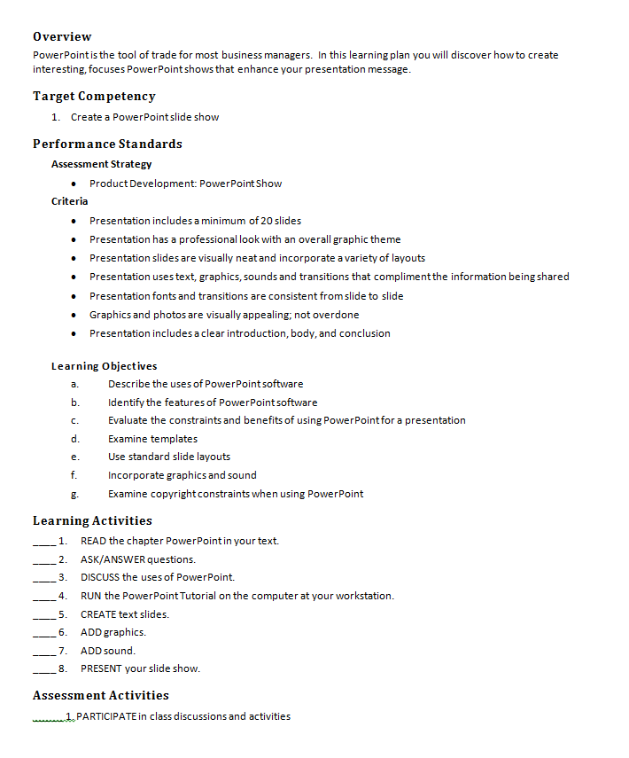

**Sample Learning Plan Practice: Suggested Answers**

SAMPLE

**Activity Sheet**



Following are suggested answers. Your answers may vary.

1. **Is there a motivational activity?**

*Not really. Most learners would not find reading a chapter in the text very motivational. How about showing a well-designed PowerPoint and set the stage for what learners learn in this learning plan?*

1. **Are there both comprehension and practice activities?**

*Yes there are—but the chunking of the learning isn’t very visible. Think about ways these activities could be chunked more effectively.*

1. **Does the assessment activity match the competency assessment strategy?**

*No. The assessment activity is to participate in class discussions and activities—but the performance standards indicate the learner will complete a PowerPoint. Make sure there is a match here! (In this case, the performance standards lay out an excellent assessment strategy!)*

1. **Do the activities relate to the learning objectives?**

*In some cases the link is clear. In other cases—we don’t know. It’s hard to tell, for example, what might be covered in the textbook reading without seeing details, such as the topic of the reading assignment. Always check to make sure you have addressed all of the learning activities in one way or another.*

1. **Are the learning activities clear?**

*No. The first learning activity says, “Ask/Answer questions.” What does that mean? Learning plans are the most useful when they provide meaningful directions to students. That way a learner can take responsibility for his/her own learning.*

**How to Create a New Learning Plan**

**Information Sheet**



1. 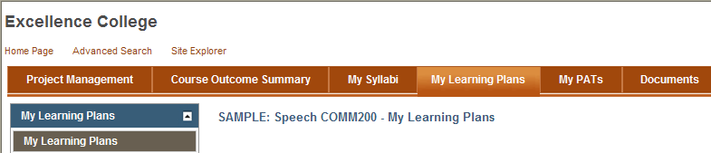**Open** your course.
2. Navigate to the **My Learning Plans** tab.
3. Click **Edit.** There are two grids on the page:

* **My Learning Plan Collection:** All learning plans start here. These are learning plans that belong to you. You are the only person who can see them unless you decide to share them.
* **Course Learning Plans:** These learning plans have been designated in the Course Outcome Summary tab as belonging to the college. You can only edit these learning plans if you have a Developer role in the course.

1. In the top grid, click **Add**.

* 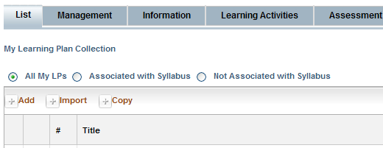**Add:** Create a new learning plan
* **Import:** Copy a learning plan from another course. (For example you might have a similar learning plan in another course you want to use as a starting point.)
* 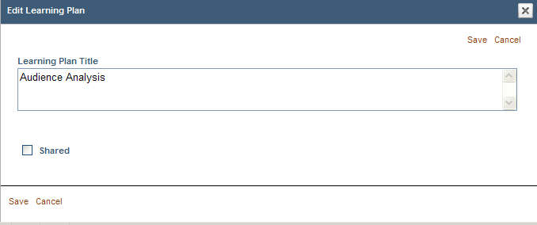**Copy:** Copy a shared learning plan from this course. This option shows you both your own shared learning plans as well as those shared by other instructors teaching this course. If there are no shared learning plans, this will be empty.

1. WIDS presents a text box for you to add a title for your learning plan. Since a learning plan is generally created for a single competency, or two related competencies, you might want to give it a title descriptive of the competency. For example, if the competency is, “Tailor a presentation to a specific audience” you may title the learning plan “Audience Analysis”.

**Check the Shared box if you want others to be able to view or copy your learning plan. *Note: you must select Shared to make it a college-owned or “Course” learning plan later.***

1. 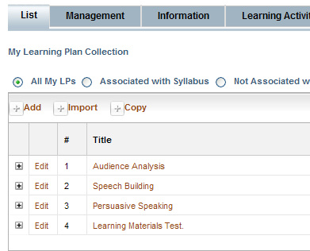Click on the learning plan title in the grid to begin developing it. Or, simply click on the **Information** tab and select the learning plan title from the drop list.

**Clicking edit next to the learning plan title allows you to edit the title and change the shared properties.**

1. 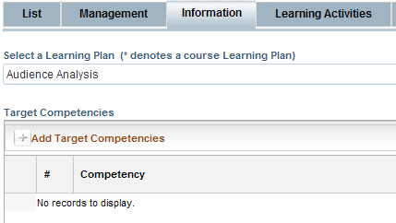When you click the title, WIDS opens the **Information** tab. (The **Management** tab is mostly read only data—although you may enter **Development Notes** there.) Click **Add Target Competencies** to link your learning plan to one or more competencies.
2. WIDS opens a dialogue box with the competencies for the course. (Note that you cannot add or edit competencies here. You must do that in the **Course Outcome Summary** tab. The dialogue box is showing the competencies you entered in the course outcome summary.)

Typically, a learning plan is linked to a single competency, or sometimes 2-3 related competencies. Select the competency or competencies your learning plan will focus on by checking one or more boxes.

To see the competency’s performance standards and learning objectives, click the + sign next to the competency.

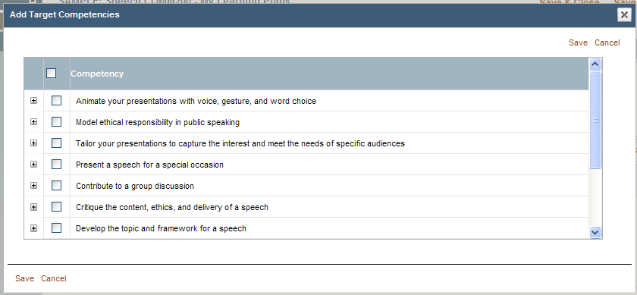

1. Enterthe **Overview / Purpose** for the learning plan. The overview is written directly to the learner. In the overview, orient learners to the learning plan. The intent is to hook their interest and motivate them to complete the activities in the learning plan. This will print at the top of the learning plan as an introduction to it.
2. Select the **Learning Activities** tab to move to the next section.
3. 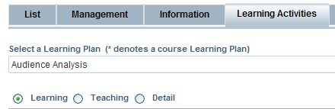Select your view of the learning plan activities.

* **Learning**: View the learning cycle and the learning activity.
* **Teaching**: View the learning cycle, learning activity, learning materials, and teaching notes.
* **Detail:** View all available data.

*Tip: It’s easiest to design in either the Learning or Teaching view. The view always defaults to Learning when returning to this screen.*

1. You can add learning activities in three ways:

**Add New Learning Activity**: WIDS presents a dialogue box where you can enter the cycle, the learning activity statement, the teaching notes, learning materials and learning activity properties.

**Import Learning Activities from Text**: WIDS presents a dialogue box where you can type or copy/paste learning activity statements. *Note this only allows entry of learning activity statements—you cannot add teaching notes, learning materials, or learning activity properties this way.*

**Import From a Bank or Library**: WIDS presents a dialogue box where you can reuse learning activities:

* **Bank:** Copy learning activities from this course or another course.
* **Library:** Copy learning activities from the WIDS Learning Activity Library.

1. To **Add New Learning Activities**:

* Click **Add New Learning Activity**. WIDS presents a dialogue box for data entry.
* Select the phase of the learning cycle from the **Learning Cycle** dropdown.
* Key in the learning activity statement. (This is what you want the learner to do. For example, you might enter: “COMPLETE the Speech Making Wheel handout.”)
* If desired, key in your notes for leading the activity in the **Teaching Notes** box.
* Optional: Complete items on the **Activity Detail** tab.
* If desired, upload or designate related learning materials (handouts, presentations, websites, etc.) in the **Learning Material** tab.

1. To **Add a Learning Activity from the Library**:

To help you design learning activities, WIDS includes an extensive learning activity library. You can use these as starting points for your own learning activities.

* Click **Import form a Bank or Library**. WIDS presents a dialogue box. Select **Learning/Assessment Activities Library**. WIDS presents a variety of learning activities.
* You can search the library using the search criteria at the bottom of the library dialogue box.
* To add an item from the library, check one or more activities and click **Save**.

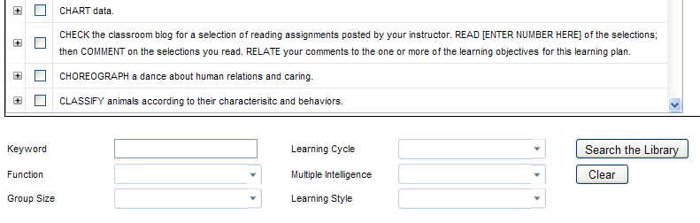

1. Select the **Assessment Activities** tab to move to the next section.

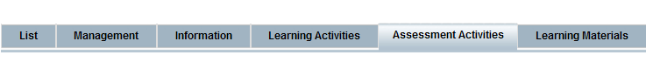

Assessment activities represent the assignments learners will complete or submit to demonstrate mastery of the competencies designated in the learning plan. A learning plan may have more than one assessment activity. Assessment activities might reference a performance assessment task you have created. Examples might include:

* SUBMIT the Audience Analysis form.
* COMPLETE the Audience Analysis performance assessment task.

Add one or more assessment activities for your learning plan.

1. Select the **Learning Materials** tab to move to the next section.

Learning materials for a learning plan can be added directly to the **Learning Materials** tab. They can also be added when creating or editing learning activities and assessment activities. When materials are added to learning activities or assessment activities, they are compiled in the **Learning Materials** tab.

* Click **Add New Learning Material**. WIDS present a dialogue box for you to complete.
  + - Select the **Documents** tab and click **Upload Documents**. This opens a window where you can select a file to upload.
    - Click the **Browse** button to see a list of folders and files available on your computer. Click the file you want to upload and click **Open**. This will close the browse window.
    - Click **Attach File(s)** to upload them to WIDS. The file you uploaded will be listed in the **Documents** tab as checked.

**How to Share Learning Plans for Collaboration**

**Information Sheet**



|  |  |
| --- | --- |
| 1. Create your learning plan in My Learning Plans tab. |  |
| 1. Make sure the learning plans you want to collaborate on are “shared.”   If it is not shared, click **Edit** next to the learning plan title. WIDS opens a dialogue box. Check the **Shared** box. | **Make sure the learning plan is shared** |
| 1. Navigate to the **Course Outcome Summary** tab. |  |
| 1. Select the **Course LPs/PATs** section and open the **Course LPs/PATs** screen. Click **Edit**. |  |
| 1. Click **Add Course Item**. |  |
| 1. WIDS presents a dialogue box with the learning plans and PATs you have shared on two tabs (**LPs** and **PATs**). Select the items you want to associate with the course. This will allow others who have editing rights on the course outcome summary, such as Developers or Managers, to collaborate on the item. Click **Save**. |  |
| 1. If you navigate back to the **My Learning Plans** tab you will see that the learning plans have moved to the **Course Learning Plans** grid. Reminder: Everyone with editing rights on the course outcome summary, such as Developers or Managers, will be able to view and collaborate on the learning plans in this section. | **These learning plans are visible to everyone in the course and can be edited by anyone with editing status on the COS.** |

**How to Set the Order for Learning Plans or PATs**

**Information Sheet**



When you navigate to the **My Learning Plans** (or **My PATs**) tab you will see two grids on the **List** tab. The top grid, **My Learning Plan (or PAT) Collection**, shows items that belong to the user. These items are not visible to anyone else. The bottom grid, **Course Learning Plans** (or **Course** **PATs**) shows items that are shared with everyone who has access to this course. These grids represents the collection of learning plans (or PATs) available to the user for linking to a course outcome summary or syllabus. **You cannot reorder learning plans on this screen.**

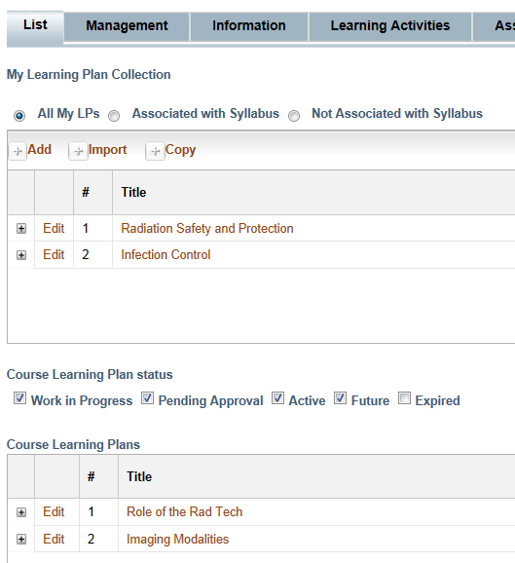

**Learning Plans (and PATs) are ordered when they are linked to the COS or a syllabus.**

# To Order Learning Plans in the Course Outcome Summary (COS)

|  |  |
| --- | --- |
| 1. Create your learning plan in **My Learning Plans** tab. | **Make sure the learning plan is shared** |
| 1. Make sure the learning plans are “shared.”   If it is not shared, click **Edit** next to the learning plan title. WIDS opens a dialogue box. Check the **Shared** box. |  |
| 1. Navigate to the **Course Outcome Summary** tab. |  |
| 1. Select the **Course LPs/PATs** section and open the **Course LPs/PATs** screen. Click **Edit**. |  |
| 1. Click **Add Course Item**. |  |
| 1. WIDS presents a dialogue box with learning plans and PATs you have shared on two tabs. Select the items you want to associate with the course. This will allow others who have Developer rights on the course to collaborate on the item. Click **Save**. |  |
| 1. WIDS lists both the learning plans and PATs you added in the grid on the screen.   To reorder them, click on one of the grid rows to drag and drop it into the preferred order. You can comingle learning plans and PATs. | **Drag and drop the rows into order** |
| 1. To print course learning plans and PATs in order, expand the **Quick Prints** section to see reports available.   **Course Design:** Prints COS followed by the learning plans and PATs in the order defined on the **Course LPs/PATs** screen.  **Course Teaching Plans:** Prints teaching plans in order. |  |
| 1. If you navigate back to the **My Learning Plans** or **My PATs** tab you will see that the selected items have moved to the **Course Learning Plans** or **Course PATs** grid. They will also represent the order defined on the **Course Outcome Summary** tab. | **These learning plans are visible to everyone in the course and can be edited by anyone with editing status on the COS.** |