Performance Standards

**Information Sheet**



***Definition***

**Observable and measurable assessment strategies and criteria of performance assessment.**

**Assessment Strategy: The tool or method used to gather evidence as to whether or not a learner can demonstrate the competency.**

**Criteria: Establish specifications by which performance will be evaluated. Criteria form the basis of the checklist or rubric used for evaluation.**

**DEFINITION**

***Competencies***

*Performance standards* provide tools for clarifying performance expectations. They help define the skill in the competency and clarify the required levels of performance. Performance standards include both assessment strategies and criteria.

* *Assessment Strategies* name the situation and/or tool (case study, role play, paper, skill demonstration, etc.) used for assessment of the competency.
* *Criteria* provide the basis for answering the question, “Did the learner achieve the competency?” They describe important characteristics or expectations for evaluating the learner’s performance of a competency. In the WIDS software, criteria form the basis of a rubric or checklist used to evaluate the competency.

***Performance Standards Checklist***

* Assessment strategy names the tool or method used to assess the competency
* Criteria form the basis for the checklist and/or rubric used to assess competency performance
* Criteria begin with the name of the product when they measure a project and the word “learner” or “you” when they measure a process
* Criteria give measurable and observable specifications for the product or process that will be assessed
* Criteria give the learner “up front” information about what is expected so the learner can take responsibility for producing acceptable work
* Criteria do not use instructor judgment as a reference, although they may refer to a checklist developed by the instructor

### Why Write Performance Standards?

Learners perform best in assessment activities where instructors make expectations explicit and provide detailed instructions. Performance standards help define expectations so learners never have to guess what the teacher wants!

### How to Identify Assessment Strategies

Determine what the product or process that will be for assessment. Make sure the assessment strategy allows learners to demonstrate the competency. Assessment strategies usually do not include homework assignments, class discussions, or strictly knowledge based quizzes and tests.

### How to Write Criteria

Begin developing criteria by listing whether you are evaluating a product, a process or both. If you are evaluating a product, imagine the ideal product. Make a list of the characteristics of the product and write a criterion statement for each characteristic. You might include criteria for all of the following:

* Content
* Format
* Productivity skills

If you are assessing a process, make a list of the steps in the process that will be observed for the sake of assessment. You may also include any of the following:

* Speed
* Permissible errors
* Accuracy or tolerance
* Percent or number

### Sample Performance Standards

|  |  |  |  |  |
| --- | --- | --- | --- | --- |
| **Competency:** | Create a marketing plan |  | **Competency:** | Maintain patient records |
| **Performance Standards** | |  | **Performance Standards** | |
| Assessment Strategy | * Marketing Plan Project |  | Assessment Strategy | * Role Play Simulation |
| Criteria | * marketing plan includes a description of the target market * marketing plan includes pricing strategy * marketing plan includes the outline of the selling strategy |  | Criteria | * you type in the patient name, address, and phone number * you apply the appropriate labels to the folder * you file the folder |

Sample Performance Standards

**Information Sheet**



Following are sample performance standards. Additional examples can be found in the WIDS Performance Assessment Task Library. Examples should be updated to address course-specific performance expectations.

1. Case Study

Assessment Strategy

* Case study

*Criteria* – Your performance will be successful when:

* case study response demonstrates a thorough understanding of relevant aspects of the case
* case study response outlines in detail the decision selected by the learner
* case study response includes an explanation of why the decision was selected
* case study response is supported by relevant evidence
* case study response is well organized
* case study response evidences correct grammar, punctuation, and spelling

2. Lab Report

Assessment Strategy

* Lab Report

*Criteria* – Your performance will be successful when:

* lab report includes a title page with the title of the experiment, the date it was performed, and the names of the people who conducted the experiment
* lab report includes an overview of the procedure used for the lab
* lab report includes a list of the materials, equipment, and steps used to conduct the experiment
* lab report includes a summary of the results
* lab results are presented in a chart, graph or drawing
* lab report is word-processed or neatly handwritten
* lab report is well organized; sections are clearly marked with appropriate headings

3. Machine start-up

Assessment Strategy

* Skill demonstration

*Criteria* – Your performance will be successful when:

* you load the program into the CNC machine
* you review documentation to acquire the information necessary for production of the part
* you set the origin, install tooling, and set tool offsets without errors
* you perform tape verification
* you perform a dry run to check the program errors
* you use all measures and avoid crashes

Performance Standards Tips

**Information Sheet**



Competencies describe the target outcomes for your course. Those outcomes are clarified further when you develop performance standards. Performance standards provide tools for clarifying your expectations for students so they never have to wonder what the teacher wants! They tell students how they will be assessed (assessment strategy) and the criteria you will use to assess them.

### Performance Standards include:

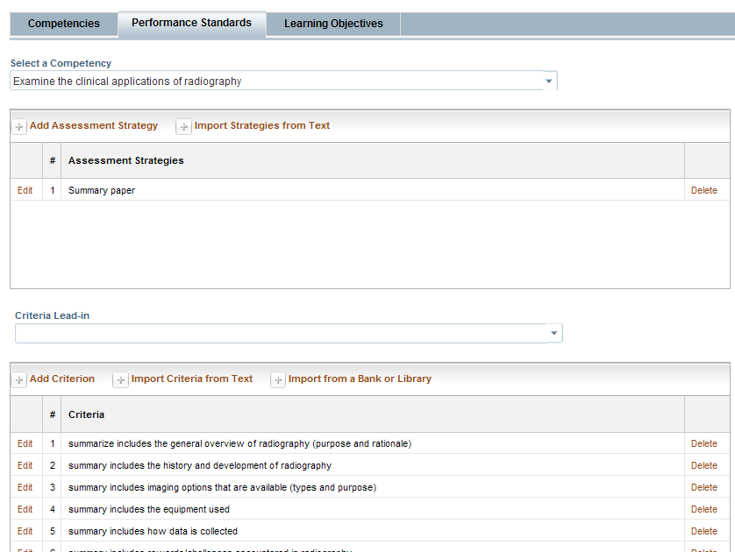

**Designate the assessment strategy by clicking here. WIDS presents a dropdown of options—or type in your own.**

**More than one assessment strategy can be added.**

**Add criteria here. You can use the Import Criteria from Text option to enter several criteria at once. Try using the Library to get ideas for your criteria. Later, you can use your criteria to create scoring guides or rubrics in WIDS.**